Mankind after the Fall:
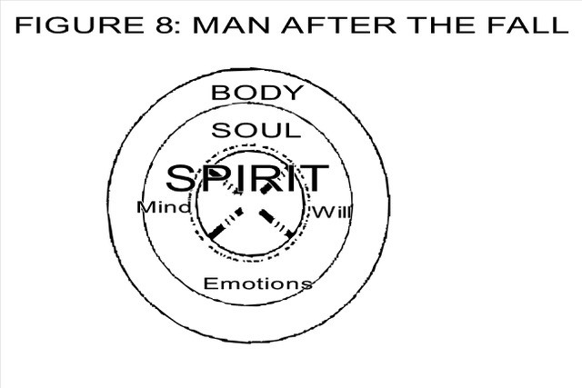
Adam was the federal head of all the government of God, so when he fell his seed fell.
We, as fallen man, are born in the image of the first Adam.
Gen. 5:3
“Adam begot sons in his own image.”
Body – mortal, corruptible, “dead”
Soul – soul is now corrupted: Mind – carnal; Emotions – warped; Will – rebellious
Spirit – bound (chained) and dead – separated from God; a veil shuts off the inner part of man where God was to make His home.

Eph. 2:1
“You whom He has quickened who were dead in trespasses and sins.”
Mankind in the image of fallen Adam:
Image of God: Image of Adam:
- Illuminated Darkened
- Intelligent Dumb
- Immaculate Defiled
- Infinite Defeated
- Immutable Decayed
- Inherited Disowned/disinherited
- Immortal Dead
Wrong doing: Judgments
Adam Gen. 3:17-19
Fallen woman Gen. 3:15-16
This is not the divine order for man and woman but the consequences of their fall.
The subjection of women to men to greater or lesser extent in cultures throughout the ages are not God’s divine order but fallen man’s “doctrine of divine order.”

The Fall:

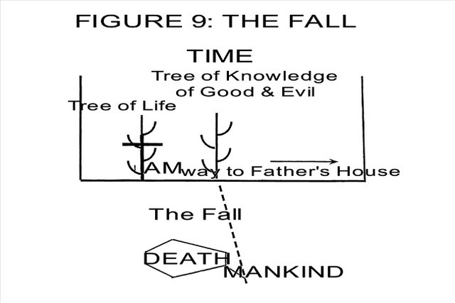

Through his choice of disobedience, man became an immoral being. As man sinned in disobeying God, he literally fell down from his position in God’s Eternal Plan, the place where the Father was bringing him to maturity to rule and reign with Him forever. Adam lost the way home to Father’s house.

